AKSA Equipment Inspection Database User’s Guide

Overview 2
Opening the Application 2
Inspections 4
Finding an Equipment Item 4
Viewing an Inspection 7
Editing an Inspection 9
Entering a New Inspection 12
Printing a Form for a Written Inspection 13
Printing an Existing Inspection 16
Printing Technical Data 17
Reports 18

Overview
The AKSA Equipment Inspection Database provides a convenient, web-based interface for entering, editing and printing equipment inspection data sheets and maintaining inspection schedules. This document describes the procedures for opening the application, entering new or editing existing inspection data, printing inspection sheets, and running reports for inspection scheduling.

Opening the Application
A link to the Equipment Inspection Database is located on the AKSA intranet home page under the “Maintenance” header (Figure 1).

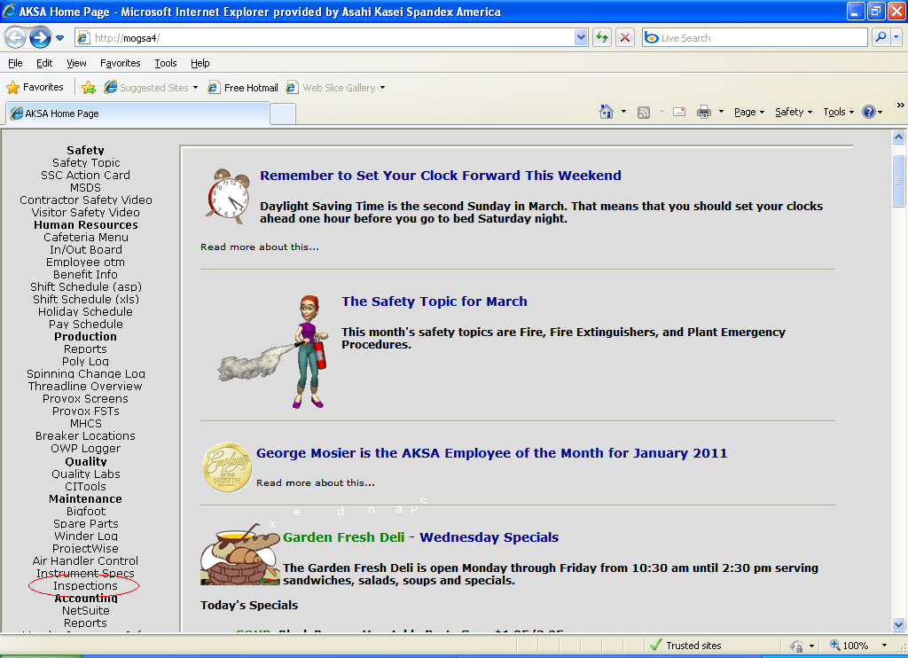
Figure 1

Clicking this link will display the application main menu. Items on this page may or may not be displayed, based on the user’s permission level. For example, a technician who only needs to be able to enter inspections and run reports would only be given a limited number of options (Figure 2), but an engineer or maintenance supervisor who has responsibilities for maintaining technical data would have more options (Figure 3).

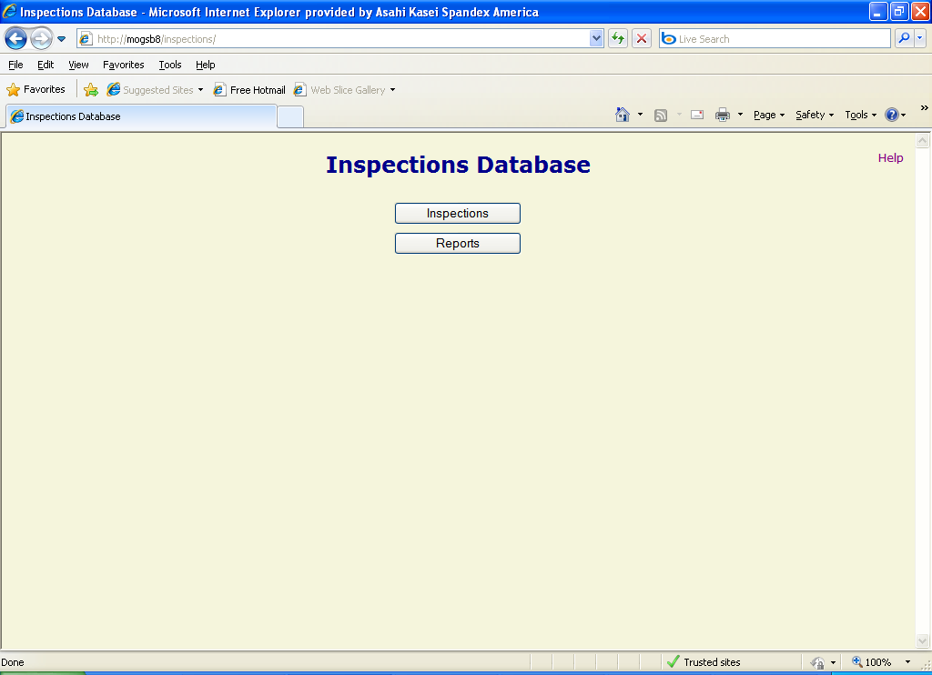
Figure 2

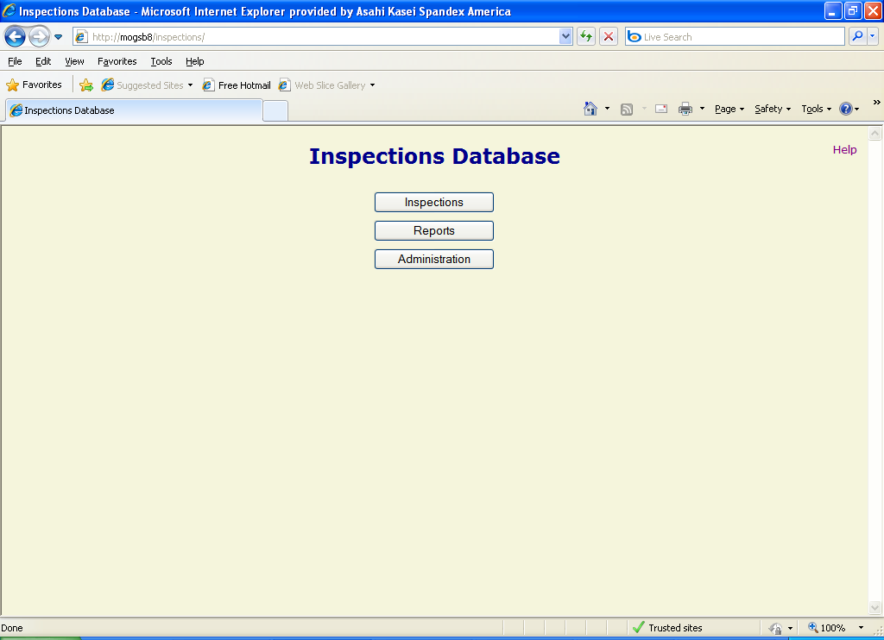
Figure 3

Inspections
The application allows users to enter a new inspection, edit and print an existing inspection, or print a form to allow a hand-written inspection.

Finding an Equipment Item
A filtering system is provided to allow users to select an item for an inspection process. Clicking the “Inspections” button from the main menu opens the “Select Equipment Item” Form (Figure 4). This form allows the user to supply search criteria to easily find the item desired.

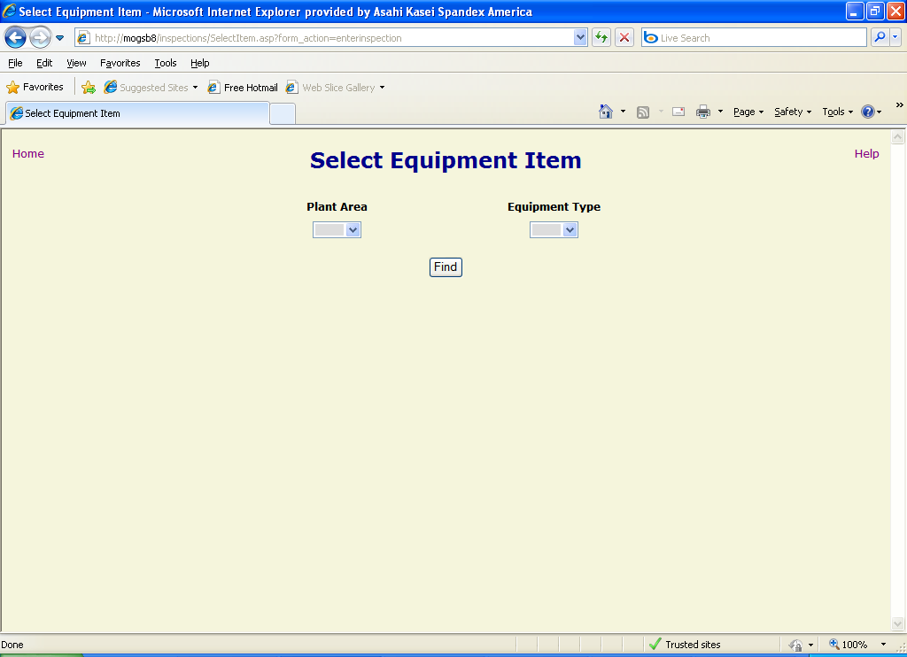
Figure 4

This screen presents two filter selections in dropdown lists:

- Plant Area – the process area to which the equipment is assigned (e.g. 0230).
- Equipment Type – the process type of the equipment (e.g. PSV, Tank, etc.).

When the desired filter criteria have been specified, click the “Find” button to view the matching results (Figure 5). The items returned will have to meet each of the conditions selected. For the example in the figure, the items shown in the list box are all assigned to area 0230 and are all Process Safety Valves (PSV). The result list box displays the equipment item tag and description.

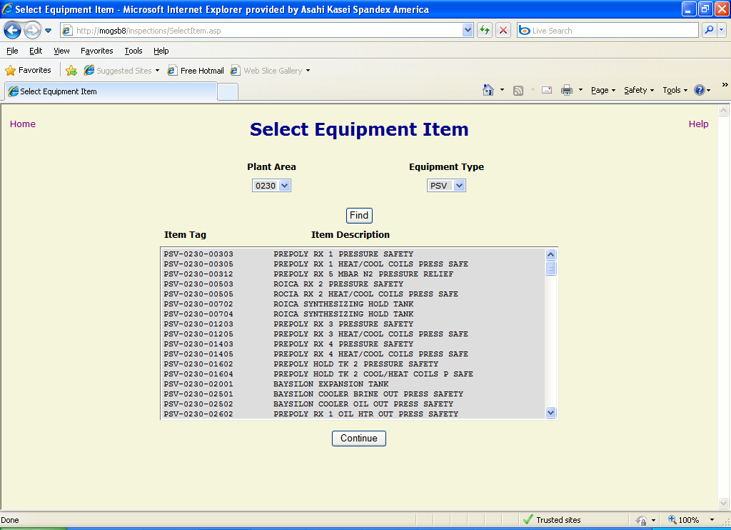
Figure 5

To proceed, double-click on the desired item in the list box or select it and click the “Continue” button. This will display the Select Inspection form. If no previous inspections have been entered for the selected item, this form notifies the user of this and displays buttons to allow the user to do one of the following actions (Figure 6):

- Enter New Inspection – Enter a new inspection for this equipment item utilizing the on-line form.
- Print Inspection Form – Print a blank form to allow a hand-written inspection to be performed.
- Print Technical Data – Print a sheet that details the technical details of this equipment item.

If one or more existing inspections exist for the selected item, the form displays information about the existing inspections (the inspection date and the name of the person who performed the inspection) in a list box and provides extra buttons to allow the user additional functionality (Figure 7):

- View/Edit Inspection – Open the on-line inspection form to view or modify the selected inspection data, based on the user’s privileges.
- Print Inspection – Print the data associated with the selected inspection.

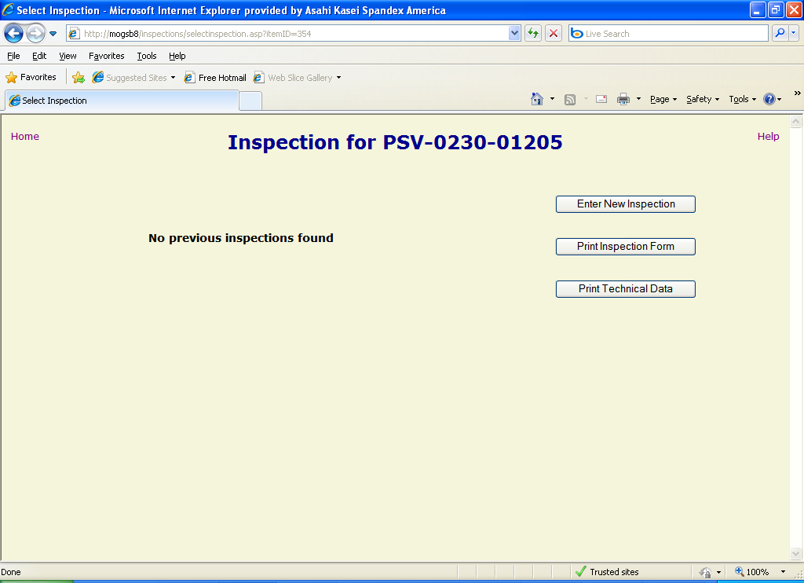
Figure 6

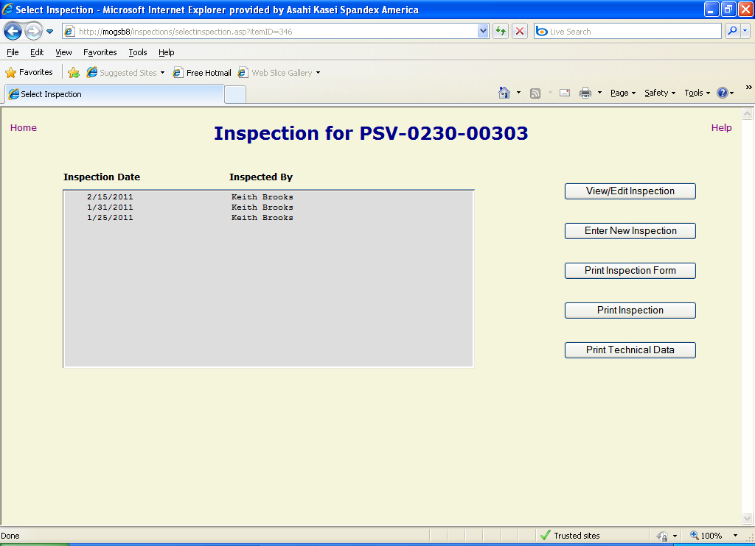
Figure 7

Viewing an Inspection
If the user does not have privilege to enter or edit inspection data, clicking the “View/Edit Inspection” button on the “Select Inspection” form will bring up the inspection report form for the selected inspection in read-only mode (Figure 8). If the user has not first selected an existing inspection from the list box, a warning will be displayed (Figure 9).

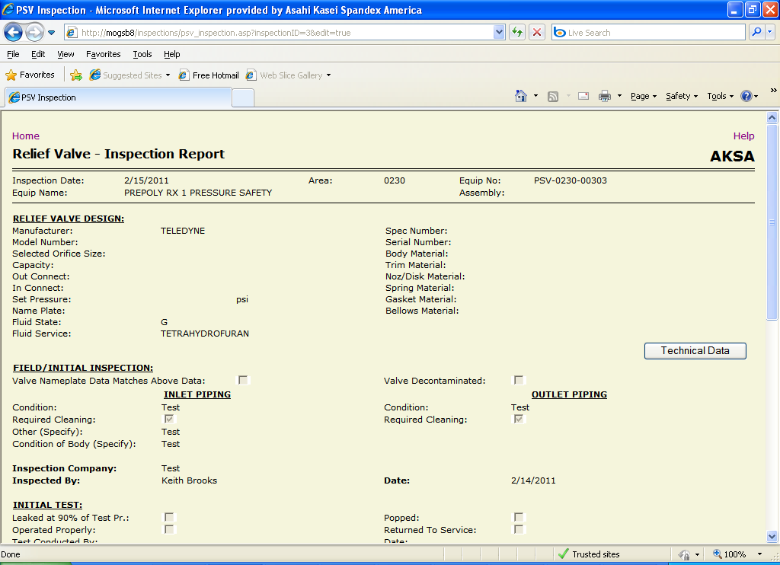
Figure 8

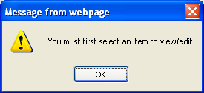
Figure 9

While viewing an inspection report, the user may click on the “Technical Data” button to view the item’s associated technical data, which will open in a new browser tab or window (depending on the local browser settings) (Figure 10).

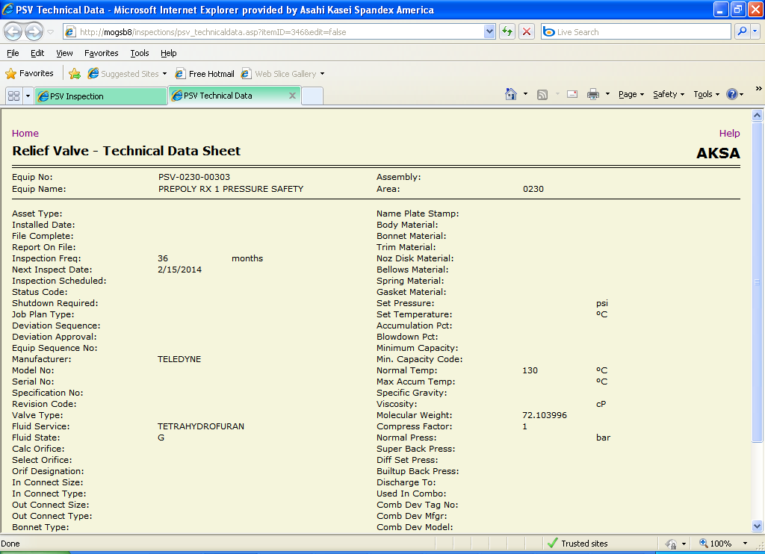
Figure 10

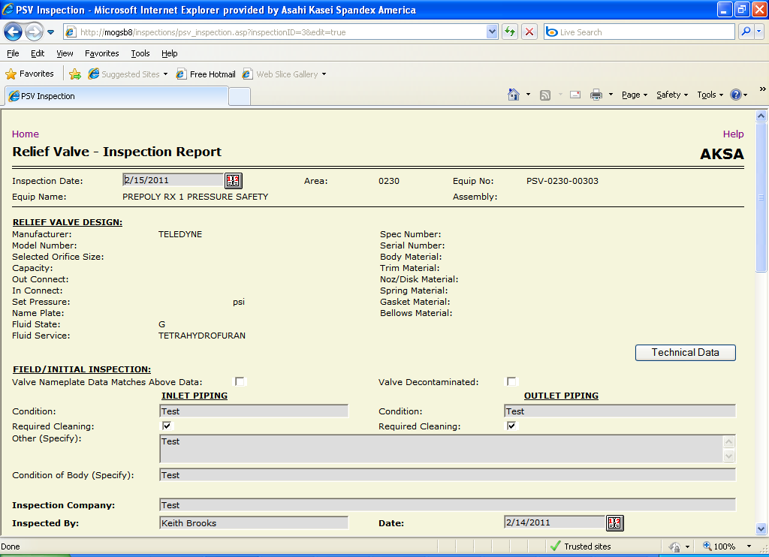
Figure 11

Editing an Inspection
If the user has sufficient privilege, clicking the “View/Edit Inspection” button on the “Select Inspection” form will open the inspection form for the selected inspection in edit mode (Figure 11). This will allow the user to modify data that has already been entered, as well as enter new data in blank fields. If the user has not first selected an existing inspection from the list box, a warning will be displayed (Figure 9).

The Inspection form contains six kinds of data fields to allow display and/or modification of the specification data:
- Static text – These are non-modifiable fields that display data about the equipment item itself, like the tag number, or about a parameter that has been specified for the item, like the previous inspection date.
- Textbox – These are single-line text fields that allow users to modify data through standard typing techniques (highlight, backspace, delete, etc.). Textboxes for data fields that are associated with dates will also have a button to the right of the field that can be used to display a drop-down calendar to allow the user to easily select the desired date by clicking on it (Figure 12).
- Text area – A multi-line text field that allows users to enter a virtually unlimited amount of character data. This field is also modified using standard typing techniques.
- Dropdown list – These fields allow users to select an entry from a pre-defined list to simplify data entry and provide data consistency. The user simply clicks on the down-arrow beside the field, scrolls through the resulting list of values, and then selects one by clicking it.
- Checkbox – This allows easy entry for yes/no type of data. When the check is displayed the value is “Yes”, when it is not displayed the value is “No”. The user toggles between checked and unchecked by clicking on the box.
- Radio button – This type of control consists of a group of options displayed together, with only one option allowed to be selected at a time. The user selects the desired option by clicking on the corresponding circle, which will fill in when selected.

In order to save the inspection changes that have been made to the database, the user must click the “Submit” button at the bottom of the form (Figure 13). Once the database has been successfully updated, the user is returned to the main menu. If the user attempts to move to a different page or to close the browser before saving any changes, a pop-up message will be displayed warning that the changes will be lost (Figure 14). To keep the changes, click the “Cancel” button on the pop-up and then click the “Save” button on the “Edit Spec” form. To discard the changes, click the “OK’ button on the pop-up.

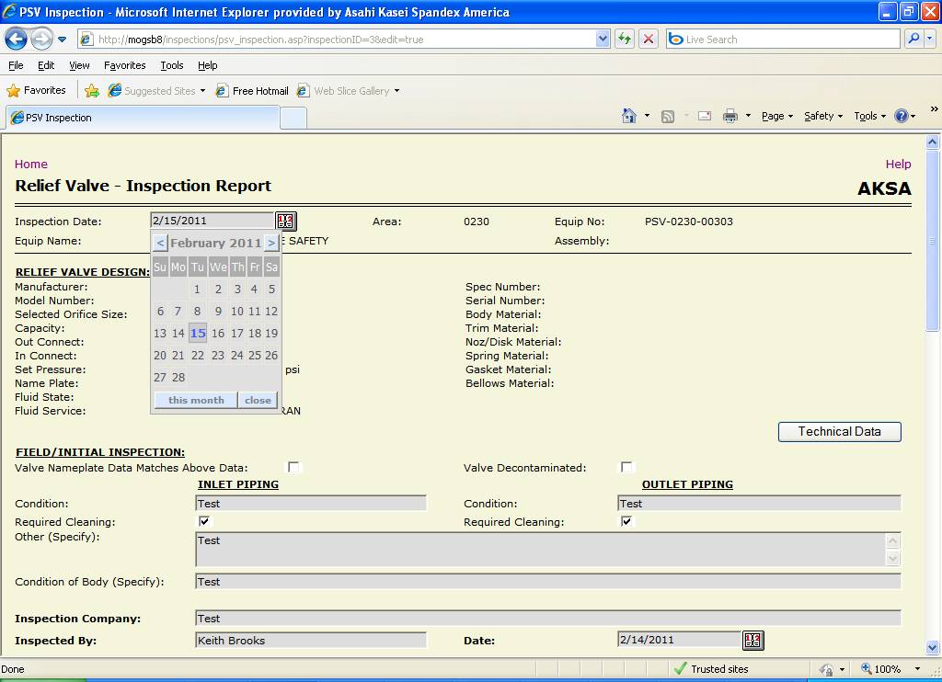
Figure 12

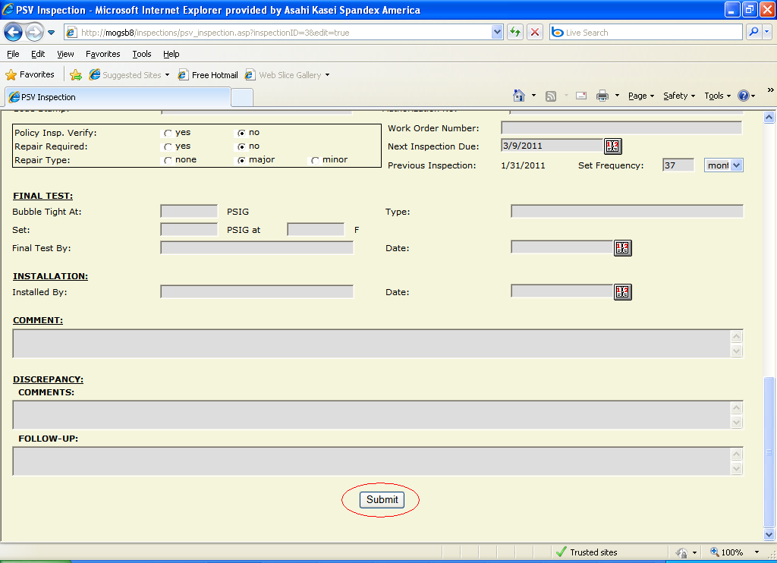
Figure 13
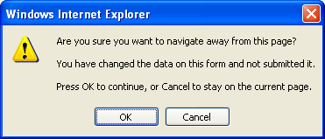
Figure 14

Entering a New Inspection
If the user has sufficient privilege, clicking on the “Enter New Inspection” button on the “Select Inspection” form will open the inspection form in edit mode with specific fields initialized to default values (Figure 15):

- Inspection Date – the current date.
- (Field/Initial Inspection) Date – the current date
- Policy Insp. Verify – “no”
- Repair Required – “no”
- Repair Type – “none”
- Next Inspection Due – If a previous inspection exists for this equipment item, this field is defaulted to the date of the latest inspection plus the set frequency. If this is the first inspection for this item, this field is set to the current date plus the set frequency.
- Set Frequency – If a previous inspection exists for this equipment item, this field and the following “units” field are set to the corresponding values in the latest inspection. If this is the first inspection for this item, the fields are set to values specified in the equipment type table for the item’s type (i.e. PSV, Tank, etc.).

See Editing an Inspection for data entry and submission requirements.

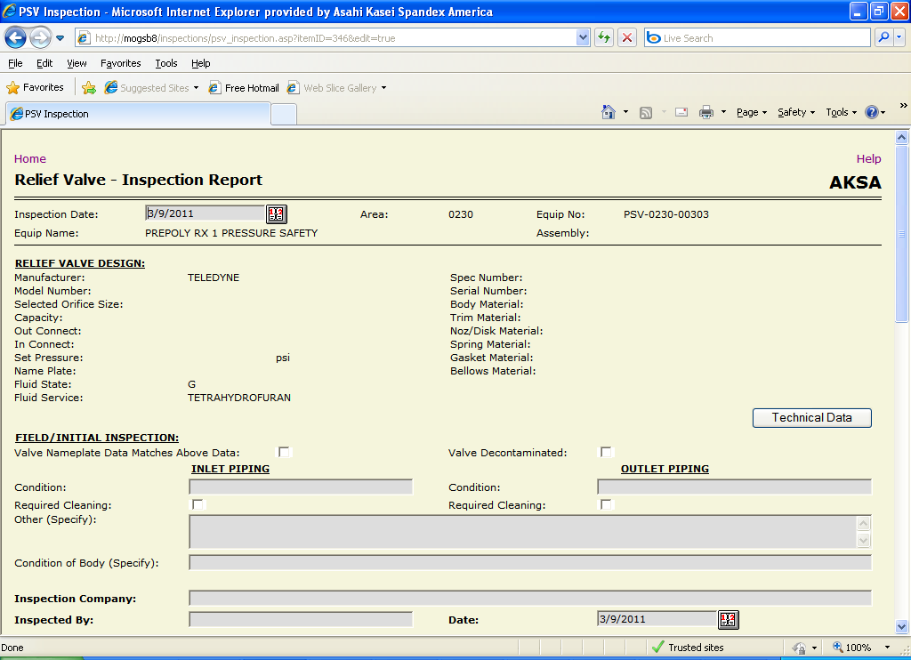
Figure 15

Printing a Form for a Written Inspection
In some cases it may be necessary to record inspection data in a written format, such as when the inspection is performed by an external company. This data must eventually be entered into the database using the on-line form, but a manual-entry form has been provided to allow ease of initial, written entry.

To print this form, the user clicks the “Print Inspection Form” button from the “Select Inspection” form. The manual entry form will open in a new tab or new window (depending on the local browser settings) (Figure 16). The user can then click the “Print” link on the form or the “Print” button on the browser toolbar to actually produce the hard-copy.

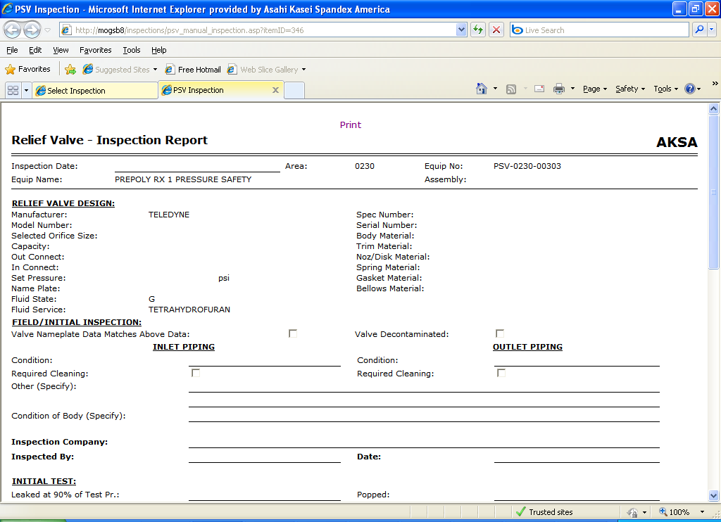
Figure 16

Unfortunately, the default print settings for most browsers specify header and footer information. The following procedure describes the steps to print the form in a more readable and professional form. NOTE: This procedure only applies to Microsoft Internet Explorer versions 7.0 and higher.

- From the browser’s “File” menu, select “Print Preview…” The page will be displayed the way that the browser will print it (Figure 17).

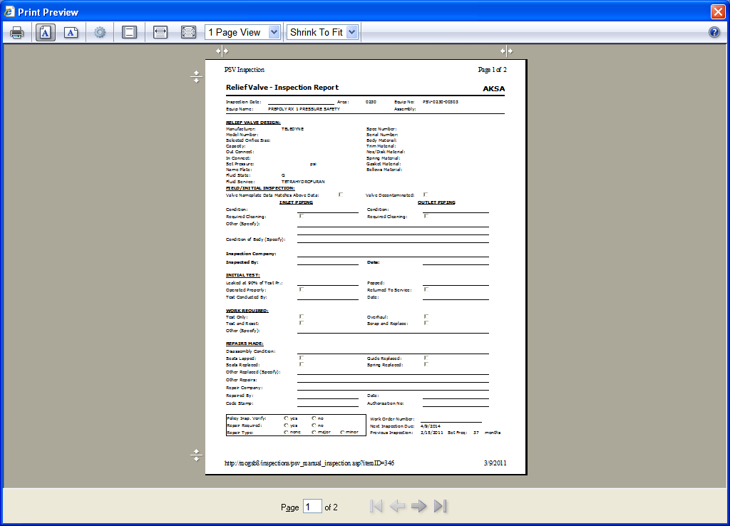
Figure 17

- On the Print Preview toolbar, click on the “Page Setup” button (Figure 18) to bring up the “Page Setup” dialog box.

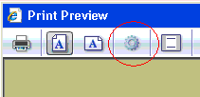
Figure 18

- On the “Page Setup” dialog (Figure 19), make the following changes:
  - Change all of the Header and Footer dropdowns to “-Empty-”.
  - Click the “OK” button to close the dialog.
- The Print Preview page will refresh to show the form as it will now print (Figure 20).
- To send the spec form to the printer, click the “Print” button on the Print Preview toolbar (Figure 21) to open the “Print” dialog box.
- In the Print dialog, select the appropriate printer, then click the “Print” button.
- Close the tab or window for the manual entry form that the system opened.
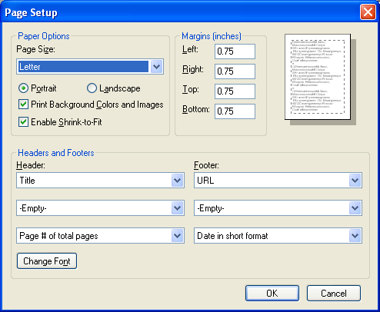
Figure 19

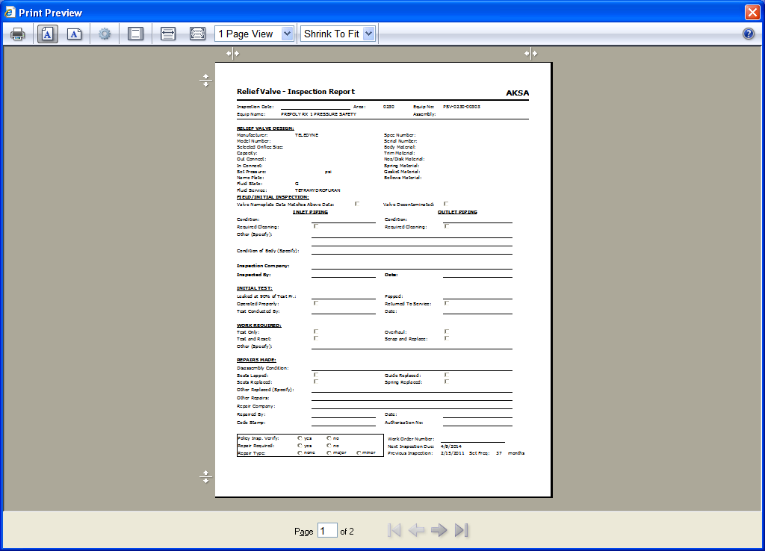
Figure 20

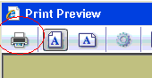
Figure 21

Printing an Existing Inspection
Select the “Print Inspection” button on the “Select Inspection” form to open a printer-friendly version of the selected inspection (Figure 22). If no inspection has been selected, an error will be displayed (Figure 23). Click the “Print” link on the form to open the print dialog to select a printer and print the document. The user may also want to first adjust the print formatting as described in Printing a Form for a Written Inspection above.

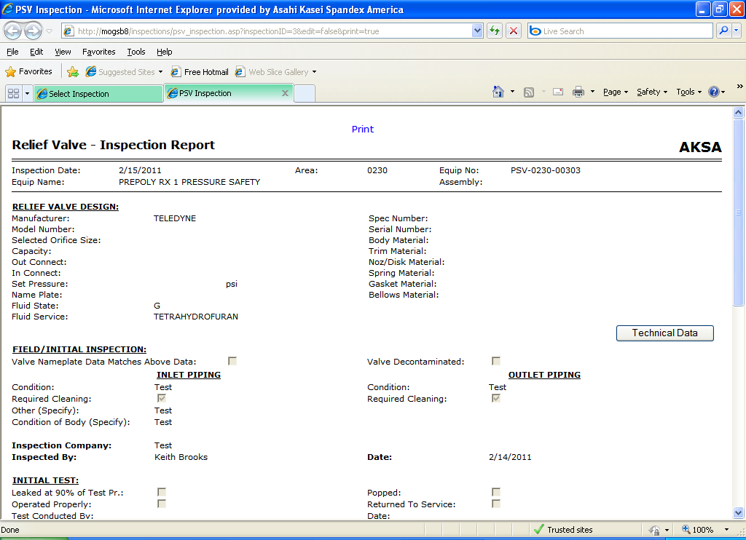
Figure 22

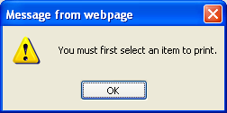
Figure 23

Printing Technical Data
Select the “Print Technical Data” button on the “Select Inspection” form to open the technical data form in a printer-friendly format (Figure 24). Click the “Print” link to open the print dialog to select an output device and print the document. The user may also want to first adjust the print formatting as described in Printing a Form for a Written Inspection above.

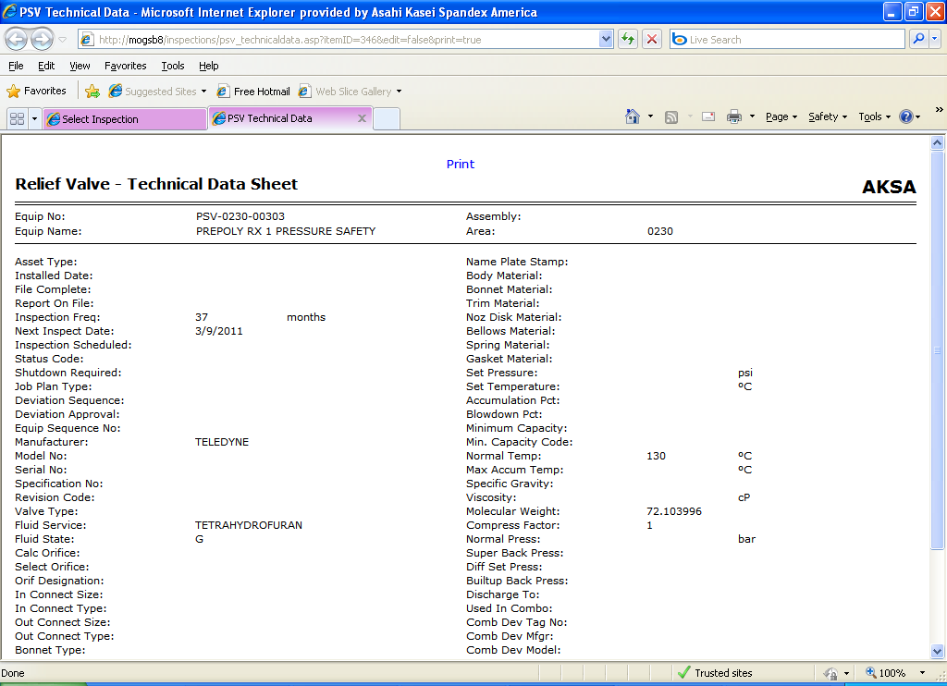
Figure 24

Reports
The application provides reporting capabilities to enable users to manage

